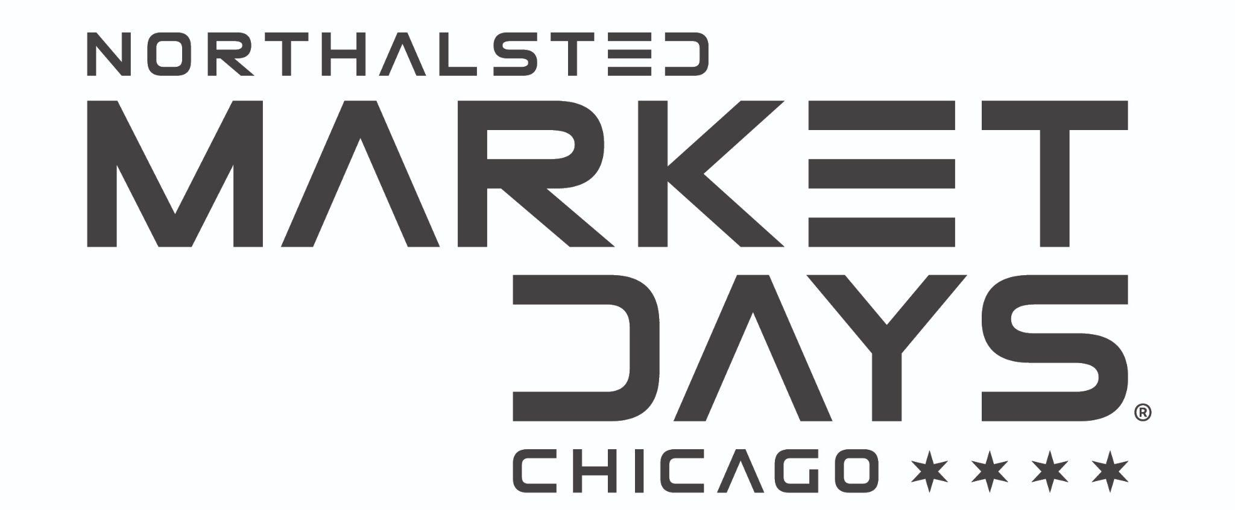

*Northalsted Market Days ®*

*c/o Special Events Management*

*2221 W. 43rd Street | Chicago, IL 60609*

*FOR IMMEDIATE RELEASE*

*Media contact: Lana Simon, 847-727-8177*

*lanasimonpr@gmail.com*

[***Northalsted 2025 Press Kit***](https://drive.google.com/drive/folders/1x_nPl-9D31RDIo9Uu56pjcEaOzpknwqj)

FOR IMMEDIATE RELEASE

**Keke Palmer, David Archuleta, Monét X Change, Joe Dombrowski, Sasha Colby and Saucy Santana to headline this year’s expanded Northalsted Market Days**® **August 8-10!**

CHICAGO —The Northalsted Business Alliance is thrilled to announce the return and expansion of this year’s Northalsted Market Days® with 4 stages featuring headliners Keke Palmer, David Archuleta, Monét X Change, Joe Dombrowski, RuPaul’s Drag Race winner Sasha Colby and Saucy Santana taking place August 8-10 in the iconic Northalsted neighborhood between Addison and Belmont.

Other artists appearing include Kiesza, this season's RuPaul’s Drag Race finalist Sam Star, Brooke Eden as well as international DJs and producers: Ralphi Rosario, Alex Acosta, Danny Verde, Joe Gauthreaux, Jesus Montanez, Sam Gee, J Warren and Ron Carroll. Drag shows daily will include legendary performers Mimi Marks, Mz Ruff n Stuff, DiDa Ritz, Veronica Pop, Gina Belle, Serena Fiierce as well as a new local dance party stage that will feature local DJ talents from Northalsted venues. In addition, local favorites Sixteen Candles, Dancing Queen: An ABBA Salute, Too Much Molly Band are returning plus many more. The complete schedule will be released soon.

By popular demand, Market Days has extended to three days this year and kicks off Friday, August 8th from 5:00 p.m-10 p.m and continues Saturday and Sunday daily from 11 a.m to 10 p.m.

This festival has been an integral part of Chicago's cultural tapestry, drawing crowds from around the globe to experience the unique spirit of Northalsted, the historical center of Chicago’s LGBTQ+ community. This year's event will continue that tradition with an exceptional lineup of live performances, over 300 LGBTQ+ vendors, including local food and drinks, artisans, merchants and nonprofits.

New Gold and Platinum VIP Weekend Experience for 2025! Limited number of Gold VIP Market Days experiences will be offered for the weekend that include VIP Lounge with private air conditioned restrooms, private bar service, covered lounge seating areas, and convenient in/out festival access for $50, or select the Platinum VIP experience for $100 and enjoy 6 complimentary beverages at the VIP bar.

Festival Entry: General entry each day of the event is available for a $20 suggested donation that helps pay performers, event workers, and funds community programs.

For more information and updates, visit [marketdayschicago.com](http://marketdayschicago.com) and [marketdaysvip.com](http://marketdaysvip.com).

**About the Northalsted Business Alliance**

Founded in 1980, the Northalsted Business Alliance represents one of the nation's oldest and last remaining LGBTQ+ business districts including more than 100 small businesses along Chicago’s Halsted Street corridor from Belmont to Irving Park/Broadway. The organization works to enhance economic vitality, foster a welcoming inclusive community, celebrate LGBTQ+ culture, and promote tourism through programs, services, and events including Chicago Pride Fest®, Northalsted Market Days®, the Haunted Halsted Halloween Parade, support of Chicago’s Annual Pride Parade and more. For information visit [northalsted.com](https://northalsted.com/).

###